**Lab Exercises**

Class: Name: StuID:________________

Date: Score:

**Lab Exercise 1 — Modifying Class Account**

**I Lab Objectives**

In this lab, you will practice:

1. Creating member functions.
2. Invoking functions and receiving return values from functions.
3. Testing a condition using an if statement.
4. Outputting variables with stream insertion and the cout object.

**II Description of the Problem**

Modify class Account to provide a member function called debit that withdraws money from an Account. Ensure that the debit amount does not exceed the Account’s balance. If it does, the balance should be left unchanged and the function should print a message indicating "Debit amount exceeded account balance." Modify class AccountTest to test member function debit.

**III Sample Output**

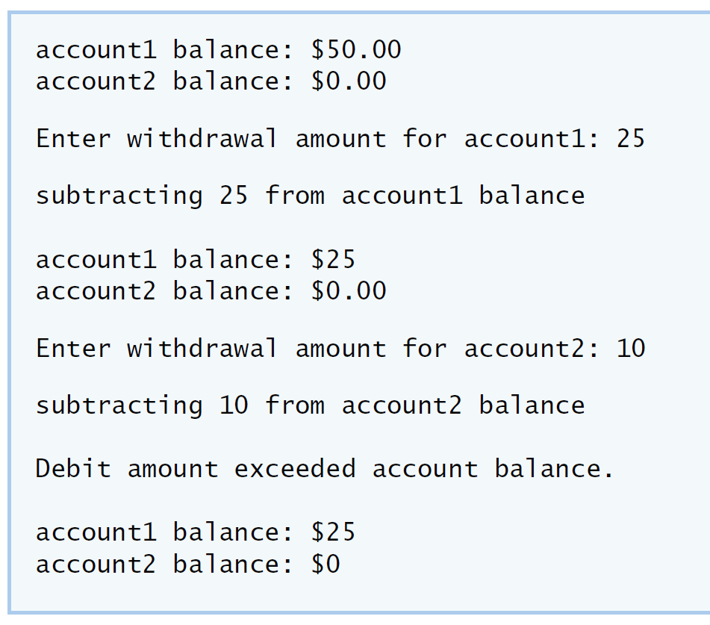

**IV Your Solution**

**Lab Exercise 2 — Modifying class GradeBook**

**I Lab Objectives**

In this lab, you will practice:

1. Declaring a data member.
2. Providing *set* and *get* functions to manipulate a data member’s value.
3. Declaring member functions with parameters.

**II Description of the Problem**

Modify class GradeBook. Include a second string data member that represents the name of the course’s instructor. Provide a *set* function to change the instructor’s name and a *get* function to retrieve it. Modify the constructor to specify *two* parameters—one for the course name and one for the instructor’s name. Modify member function displayMessage such that it first outputs the welcome message and course name, then outputs "This course is presented by: " followed by the instructor’s name. Modify the test application to demonstrate the class’s new capabilities.

**III Sample Output**

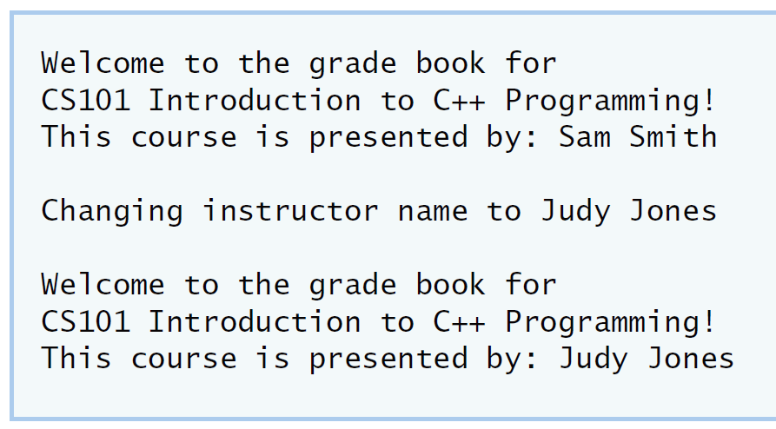

**IV Your Solution**

**Lab Exercise 3 — Creating an Employee Class**

**I Lab Objectives**

In this lab, you will practice:

1. Creating a class definition.
2. Declaring data members.
3. Defining a constructor.
4. Defining set and get functions.
5. Writing a test application to demonstrate the capabilities of another class.

**II Description of the Problem**

Create a class called Employee that includes three pieces of information as data members—a first name (type string), a last name (type string) and a monthly salary (type int). Your class should have a constructor that initializes the three data members. Provide a *set* and a *get* function for each data member. If the monthly salary is not positive, set it to 0. Write a test program that demonstrates class Employee’s capabilities. Create two Employee objects and display each object’s yearly salary. Then give each Employee a 10 percent raise and display each Employee’s yearly salary again.

**III Sample Output**

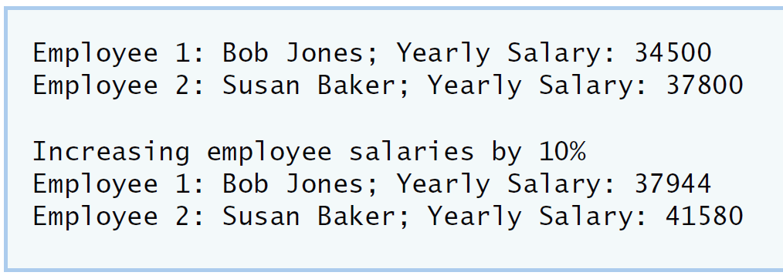

**IV Your Solution**

**Lab Exercise 4 — Complex Numbers**

**I Lab Objectives**

In this lab, you will practice:

1. Creating new data types by writing class definitions.
2. Defining member functions of programmer-defined classes.
3. Instantiating objects from programmer-defined classes.
4. Calling member functions of programmer-defined classes.

The follow-up questions and activities will also give you practice:

1. Initializing programmer-defined class data members with class constructors.

**II Description of the Problem**

Create a class called Complex for performing arithmetic with complex numbers. Write a program to test your class.

Complex numbers have the form：

realPart + imaginaryPart * *i*

where *i* is

$$\sqrt{-1}$$

Use double variables to represent the private data of the class. Provide a constructor that enables an object of this class to be initialized when it is declared. The constructor should contain default values in case no initializers are provided. Provide public member functions that perform the following tasks:

1) Adding two Complex numbers: The real parts are added together and the imaginary parts are added together.

2) Subtracting two Complex numbers: The real part of the right operand is subtracted from the real part of the left operand and the imaginary part of the right operand is subtracted from the imaginary part of the left operand.

3) Printing Complex numbers in the form (a, b) where a is the real part and b is the imaginary part.

**III Sample Output**

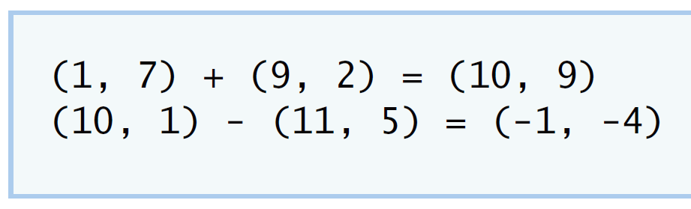

**IV Your Solution**

**V Follow-Up Questions and Activities**

1. Why do you think const was used in the parameter list of add and subtract?
2. Can add and subtract’s parameters be passed by value instead of by reference? How might this affect the design of class Complex? Write a new class definition that illustrates how the parameters would be passed by value.
3. Declare a Complex number, as follows, without passing any arguments to the constructor. What happens?Does the default constructor get called?

Complex a;

**Lab Exercise 5 — Dates**

**I Lab Objectives**

In this lab, you will practice:

1. Using access functions and utility functions so that it is not necessary for non-member functions to be able to access a class’ data members.

The follow-up questions and activities also will give you practice:

1. Overloading constructors and using default arguments with constructors.
2. Defining a destructor.

**II Description of the Problem**

Modify the Date class to provide a member function nextDay to increment the day by one. The Date object should always remain in a consistent state. Write a program that tests function nextDay in a loop that prints the date during each iteration to illustrate that the nextDay function works correctly. Be sure to test the following cases:

1. Incrementing into the next month.
2. Incrementing into the next year.

**III Sample Output**

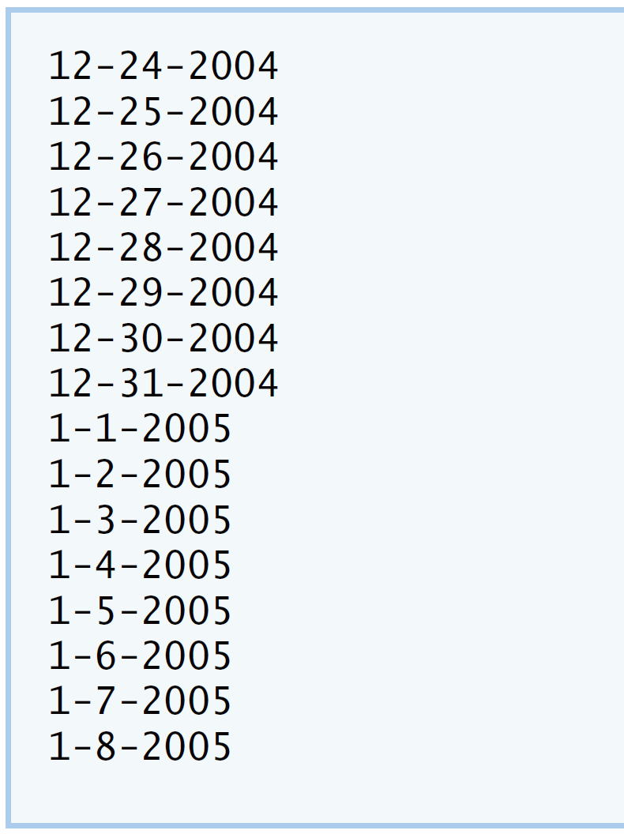

**IV Your Solution**

**V Follow-Up Questions and Activities**

1. The Date class has only one constructor. Is it possible to have more than one constructor?
2. What happens when a member function that takes no arguments is called without the parentheses (i.e.,dateObject.nextDay)?
3. Write a destructor for the Date class. The destructor should print text indicating that the destructor for the Date class was called successfully.
4. In main, try to change d’s year to 2003 using an assignment statement. Do not call function setYear. What happens? Are you able to change the value?

**Lab Exercise 6 — Simple Calculator**

**I Lab Objectives**

In this lab, you will practice:

1. Using classes to create a data type Simple Calculator capable of performing arithmetic operations.
2. Creating const member functions to enforce the principle of least privilege.

The follow-up questions and activities also will give you practice:

1. Using constructors to specify initial values for data members of a programmer-defined class.

**II Description of the Problem**

Write a SimpleCalculator class that has public methods for adding, subtracting, multiplying and dividing two doubles. A sample call is as follows:

double answer = sc.add( a, b );

Object sc is of type SimpleCalculator. Member function add returns the result of adding its two arguments.

**III Sample Output**

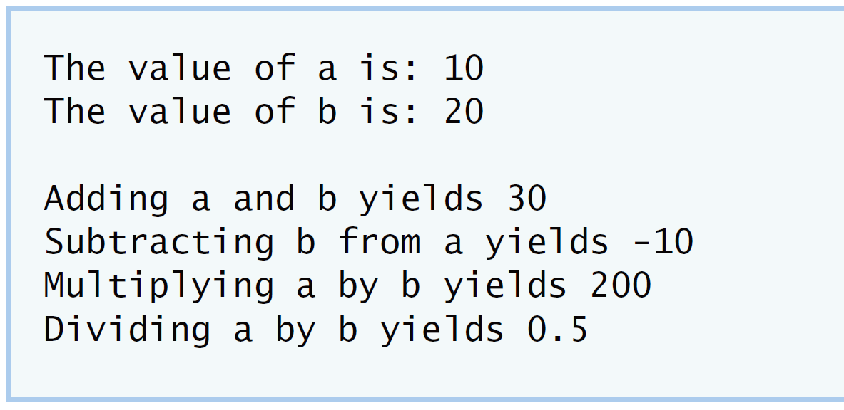

**IV Your Solution**

**V Follow-Up Questions and Activities**

1. Why doesn’t the SimpleCalculator class have a constructor?
2. Why are no private data members needed for class SimpleCalculator?
3. Modify your class so that SimpleCalculator has a private data member called answer. After performing an operation, assign the result to answer. Add a member function named getAnswer to retrieve the result of the last arithmetic operation performed by the object. Also, add a constructor for class SimpleCalculator that initializes the value of answer to 0.
4. Modify the program so that the SimpleCalculator class has an input member function that allows the user to input two doubles. The function should then store the values that were input in private data members. Use these two values for each of the arithmetic calculations. Create two constructors for this class, one that takes no arguments and initializes a and b to 0 and another that takes two doubles and initializes a and b to those values. Finally, create a member function printValues that displays the values of a and b. A segment of the driver program might now look like this:

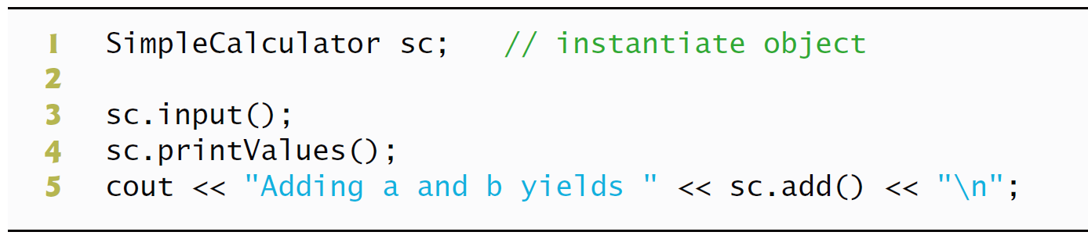

**\*Lab Exercise 7 — Integer Set**

**I Lab Objectives**

In this lab, you will practice:

1. Using classes to create a data type, IntegerSet, capable of storing a set of integers
2. Using dynamic memory allocation with the new and delete operators

The follow-up questions and activities also will give you practice:

1. Using destructors to deallocate memory that was dynamically allocated.

**II Description of the Problem**

Create class IntegerSet for which each object can hold integers in the range 0 through 100. A set is represented internally as an array of ones and zeros. Array element a[ i ] is 1 if integer *i* is in the set. Array element a[ j ] is 0 if integer *j* is not in the set. The default constructor initializes a set to the so-called “empty-set,” i.e., a set whose array representation contains all zeros.

Provide member functions for the common set operations. For example, aunionOfSets member function (already provided) creates a third set that is the set-theoretic union of two existing sets (i.e., an element of the third array’s is set to 1 if that element is 1 in either or both of the existing sets, and an element of the third set’s array is set to 0 if that element is 0 in each of the existing sets).

Provide an intersectionOfSetsmember function which creates a third set which is the set-theoretic intersection of two existing sets (i.e., an element of the third set’s array is set to 0 if that element is 0 in either or both of the existing sets, and an element of the third set’s array is set to 1 if that element is 1 in each of the existing sets).

An insertElement member function (already provided) inserts a new integer k into a set (by setting a[ k ] to 1 ). Provide a deleteElement member function that deletes integer m (by setting a[ m ] to 0 ).

A printSet member function (already provided) prints a set as a list of numbers separated by spaces. Print only those elements which are present in the set (i.e., their position in the array has a value of 1 ). Print --- for an empty set.

Provide anisEqualTo member function that determines whether two sets are equal.

Provide an additional constructor that receives an array of integers and the size of that array and uses the array to initialize a set object.

Now write a driver program to test your IntegerSet class. Instantiate several IntegerSet objects. Test that all your member functions work properly.

**III Sample Output**

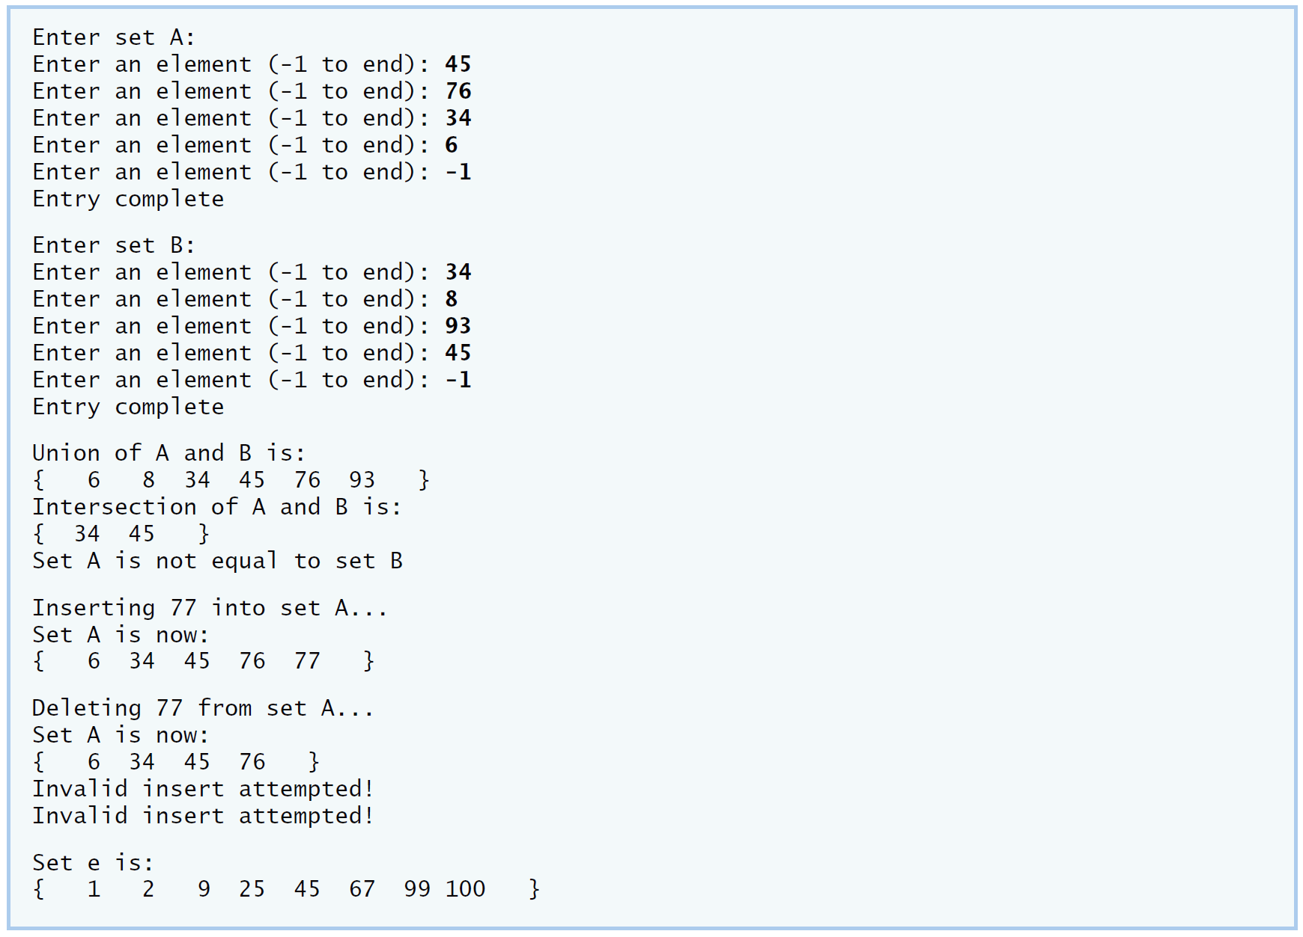

**IV Your Solution**

**V Follow-Up Questions and Activities**

1. Why might it be advantageous for the set array to be allocated dynamically using new [], if the IntegerSet class were to be used for more general sets?